Treatment Guidelines for Common Paediatric and Neonatal Diseases at Haydom Lutheran Hospital - Tanzania

by

Dr. med. Carsten Krüger, M.D.
Paediatrician, Neonatologist

Haydom Lutheran Hospital
Haydom / Mbulu-District
Tanzania

April 2000 (revised January 2003)

Preface / Acknowledgement

This booklet is an attempt to summarise possible treatment schedules at Haydom Lutheran Hospital (HLH), and to aid medical personnel in proper treatment of newborns, infants and children. It does not replace any textbook and needs to be revised from time to time due to the rapid changes in medical science!

I am very grateful to all the colleagues from Tanzania and abroad, namely Dr. Mauri Niemi of Haydom Lutheran Hospital, who contributed through their encouraging comments and criticism to the successful completion of this booklet.

Contents

Page

1 Title Page

2 Preface

3 Contents

4 Paediatrics
4 Treatment Schedules for "Common" Paediatric Diseases
4 I. Life-threatening and severe diseases
6 II. Other diseases
11 III. Other rarer diseases
12 IV. Some rarer drugs in Paediatrics
13 Protein-Energy-Malnutrition
14 Age-Weight-Height-Table
15 Intravenous Fluid Therapy in Paediatrics
16 Diarrhoea WHO/IMCI Treatment Schedules (Plan A, B, C)

19 Neonatology
19 Neonatal Resuscitation - Basics
21 Assessment of the Newborn Infant
21 Resuscitation Flow Chart
22 Physiological Background Information for the Resuscitation of Newborns
23 Kangaroo Care
24 Enteral Nutrition in Term and Preterm Newborns
25 Treatment of Term and Preterm Newborns
26 Finnström Maturity Score in Newborn Infants
27 Intra-uterine Growth Chart

28 Appendix
28 Reference Values

Paediatrics

Treatment Schedules for "Common" Paediatric Diseases

I. Life-threatening and severe diseases

Acute cardiac failure: if due to hypovolaemia give i.v. 10-30 ml/kg/dose 0.9% NaCl or Ringer's Lactate
in 30 min
if due to anaemia give slowly (over 6-8 hours) blood transfusion 10-20 ml/kg
if due to cardiogenic shock give Adrenaline/Epinephrine i.v. (in the vial you get 1:1000
dilution: make 1:10000 dilution = 1 ml Adrenaline and 9 ml NaCl): give 0.1 (-0.5) ml/kg/dose
i.v. (=0.01-0.05 mg/kg),
repeat as needed
(may be Atropine 0.01-0.03 mg/kg/dose, repeat as needed)
if due to septic shock give antibiotics and steroids and vasoconstrictors and fluids as in
hypovolaemia

Anaemia (severe): Hb below 4.5 g/dl (Hct/PCV < 14%) or Hb below 5.5 g/dl (Hct/PCV < 17%) with signs of
heart failure - blood transfusion 15-20 ml/kg over 4-6 hours, may be repeated next day;
Frusemide is not absolutely necessary! Afterwards give Folic acid and Ferrous sulfate for 4
weeks (see below)

Coma: exclude hypo-/hyperglycaemia, hypoxia, malaria, meningitis, status epilepticus, head trauma,
respiratory and/or cardiac arrest

Diabetic ketoacidosis: 0.9% NaCl i.v. 100-150 ml/kg/day + KCl 3 mval (=ml)/kg/day, first half in first 8 hours,
next half in remaining 16 hours; change to 5% Glucose i.v. if blood sugar is below 10 mmol/l
Actrapid (fast-acting insulin) 0.1 IU/kg/dose i.v./s.c. initially
(not when blood sugar < 10 mmol/l), later according to blood sugar
change as fast as possible to Insulin lente s.c. and oral nutrition!

Foreign body aspiration: immediately removal by stiff bronchoscopy

Gastroenteritis with severe dehydration: see WHO/IMCI treatment schedules (pages 16-18)

Hypertensive crisis: Nifedipine p.o. 0.25-0.5 mg/kg/dose
Frusemide i.v. 1-5 mg/kg/dose
Hydralazine p.o. 0.25-1 mg/kg/dose, maximal dose 7.5 mg/kg/day in 3 doses

Diazoxide i.v. or p.o. 5 mg/kg/dose (max. 150 mg), may be repeated after 15-25 min

Hypoglycaemia: Glucose 10% i.v. 5 ml/kg/dose stat, followed by continuous Glucose 10% infusion

Intoxications: gastric lavage - 10 ml/kg warm 0.9% NaCl per one in-out cycle through NGT
in some intoxications (like rat poison) Atropine i.v. 0.05 mg/kg/dose up to every hour

Laryngotracheobronchitis: offer enough oral fluid, place child in cool air, calm down the child,
infusion not necessary, antibiotic (like Amoxycillin) only optional (virus!)
1.) Inhalation over 15 min: Adrenaline 1 ml and 0.9% NaCl 1 ml

over nebulizer (Pariboy), can be repeated every 2-4 hours
2.) Dexamethasone i.v./i.m. 0.5 mg/kg/dose up to 3 doses per day for 2-4 days
or Prednisolone p.o. 2-4 mg/kg/day in 3-4 doses for 2-4 days

Lung oedema: Frusemide i.v. 1-2 mg/kg/dose stat, repeat as needed (3-4 doses/day)

Malaria (severe): Quinine i.v. 20 mg/kg loading dose over 4 hrs, afterwards i.v. 10 mg/kg/dose every 12 hrs
over 2 hrs in 10% Glucose; fluid restriction: 80-100% of normal requirements;
change as soon as possible to Quinine p.o. 30 mg/kg/day in 3 doses (10 mg/kg/dose)

Malnutrition: see extra guidelines (page 13)

Meningitis: < 2 months old: Ampicillin i.v. 200-300 mg/kg/day in 4 doses plus
Gentamicin i.m. 5-7.5 mg/kg/day in 1-2 doses
(later oral Amoxycillin 100-150 mg/kg/day in 3-4 doses)
> 2 months old: Benzylpenicillin i.v. 200000-400000 IU/kg/day in 4 doses plus
Chloramphenicol i.v. 100 mg/kg/day in 3-4 doses
(later oral Penicillin V 100-150 mg/kg/day in 3-4 doses)
(later oral Chloramphenicol 75 mg/kg/day in 3-4 doses)
(if available, give Ceftriaxone or Cefotaxime instead of Ampicillin/Penicillin; dosage page 12)
optional during the first 4 days: Dexamethasone i.v. 0.6 mg/kg/day in 4 doses 15-20 min
before antibiotic!
duration of intravenous treatment at least 7 days, then at least 7 days oral treatment (total at
least 14 days!); fluid restriction: 80-100% of normal requirements

Diazepam or Phenobarbitone for convulsions (see Status epilepticus)

Pneumonia (severe): < 6 years old: Ampicillin i.v. 100-150 mg/kg/day in 3-4 doses plus
Gentamicin i.m. 5-7.5 mg/kg/day in 1-2 doses for 5-7 days
(later oral Amoxycillin 50-75 mg/kg/day in 3-4 doses)
> 6 years old: same as above
or Benzylpenicillin 150000-300000 IU/kg/day in 3-4 doses plus
Gentamicin i.m. 5-7.5 mg/kg/day in 1-2 doses for 5-7 days
(later oral Penicillin V 75-100 mg/kg/day in 3-4 doses)
or Chloramphenicol i.v. 75-100 mg/kg/day in 3-4 doses plus
Gentamicin i.m. 5-7.5 mg/kg/day in 1-2 doses for 5-7 days
(later oral Chloramphenicol 50-75 mg/kg/day in 3-4 doses)
treat for 10-14 days; fluid restriction: 80-100% of normal requirements
Staphylococcus aureus pneumonia is more common in Africa and especially in children < 1 year of age. When suspected take CXR and give Cloxacillin i.v. 100 mg/kg/day in 3-4 doses in addition.
(if available, you may give Ceftriaxone or Cefotaxime instead of Ampicillin/Penicillin in
exceptional cases; dosage page 12)

Resuscitation: ABC rules (airway, breathing, circulation)
Adrenaline/Epinephrine (in the vial you get 1:1000 dilution: make 1:10000 dilution = 1 ml
Adrenaline and 9 ml NaCl): give 0.1-0.5 ml/kg/dose i.v. (=0.01-0.05 mg/kg), you can
increase up to 1.0 ml/kg/dose (0.1 mg/kg) (high dose, esp. for endotracheal application),
repeat as needed, give in asystole and in bradycardia
Volume: 20 ml/kg 0.9% NaCl or Ringer's Lactate i.v. in 20-30 min
Atropine: 0.01-0.03 mg/kg/dose i.v., repeat as needed, in bradycardia, not in asystole
Sodium bicarbonate (8.4% - dilute to 4.2%): 1-2 ml/kg/dose 4.2% slowly i.v.. Be cautious, give only if adequate ventilation is established.
Glucose 10%: 5 ml/kg/dose i.v.
Calcium gluconate 10%: 1-2 ml/kg/dose i.v.

Sepsis: 1. Benzylpenicillin i.v. 150000-400000 IU/kg/day in 3-4 doses
2. Ampicillin i.v. 150-250 mg/kg/day in 3-4 doses
3. Gentamicin i.m. 5-7.5 mg/kg/day in 1-2 doses
4. Chloramphenicol i.v. 100 mg/kg/day in 3-4 doses , if > 2 months
5. Erythromycin p.o. 40-60 mg/kg/day in 3-4 doses (occasionally)
6. Metronidazole i.v. 30 mg/kg/day in 3 doses (occasionally)
possible combinations: 1. + 4./ 2. + 3./ 1. + 3. + 4.
(if available, you may give Ceftriaxone or Cefotaxime instead of Ampicillin/Penicillin in the
most severe cases; dosage page 12)
in some cases: Dexamethasone i.v./i.m. 1 mg/kg/dose, can be repeated 3-4 times in 24 hrs
or Prednisolone p.o. 5-10 mg/kg/dose, can be repeated 3-4 times in 24 hours
treat at least for 10 days, measure blood pressure, give fluids in shock

Shock: ABC rules (airway, breathing, circulation)
Adrenaline/Epinephrine (in the vial you get 1:1000 dilution: make 1:10000 dilution = 1 ml
Adrenaline and 9 ml NaCl): give 0.1-0.5 ml/kg/dose i.v. (=0.01-0.05 mg/kg), you can
increase up to 1.0 ml/kg/dose (0.1 mg/kg) (high dose, esp. for endotracheal application),
repeat as needed
Volume: 10-20 ml/kg 0.9% NaCl or Ringer's Lactate i.v. in 20-30 min
Blood transfusion if necessary
Atropine: 0.01-0.03 mg/kg/dose i.v., repeat as needed (indicated by underlying condition)
Dexamethasone i.v./i.m. 1 mg/kg/dose, can be repeated 3-4 times in 24 hours

Status asthmaticus: Oxygen PRN
Salbutamol per inhalation 1.5-2.5 mg/dose (add 1 ml NaCl), up to 4-6 times/day
(Salbutamol p.o. 0.3-0.4 mg/kg/day; < 1 years: 1 mg x 3-4 times/day; < 5 years:
2 mg x 3-4 times/day)
or Fenoterol solution (2 drops + 1 drop per each year of age/dose) in 2 ml NaCl for
inhalation up to 4-6 times/day
and Ipratropium bromide solution (2 drops + 1 drop per each year of age/dose) in 2 ml
NaCl for inhalation up to 4-6 times/day
and Dexamethasone i.v./i.m. 0.5-1 mg/kg/day in 2-3 doses
(or Prednisolone i.v./p.o. 2-5 mg/kg/dose)
and Aminophylline i.v. 5-7 mg/kg as loading dose over 20 min,
then 15-20 mg/kg/day in 3 doses i.v./p.o.
and Adrenaline/Epinephrine (in the vial you get 1:1000 dilution: make 1:10000 dilution =
1 ml Adrenaline and 9 ml NaCl): give 0.1-0.3 ml/kg/dose s.c.(i.v.) (= 0.01-0.03
mg/kg), you can repeat after 15-30 min as needed
fluids as usual or even increased by 10%

Status epilepticus: 1. Diazepam i.v./rectally 0.3 (-0.5) mg/kg/dose over 1-5 min (max. 20 mg/dose), can
be repeated after 10-20 min. If you give rectally give 0.5 mg/kg/dose.
If fits respond but come frequently make Diazepam drip 100 mg/500 ml and give 0.1-0.4 mg/kg/h
2. Phenobarbitone i.v. 10-15 mg/kg/dose over 1-5 min, can be repeated after 10-20
min
3. Phenytoin i.v. 10-20 mg/kg/dose over 15-20 min (max. 1000 mg/dose), can be
repeated after 10-20 min (5-10 mg/kg/dose)
Be prepared for intubation!

Do not forget the possibility of hypoglycaemia!
As a last option you can give the patient general anaesthesia with thiopental
2-3 mg/kg/dose stat and then 1 mg/kg/dose prn

Thermal injuries:
Body- Day 1 Day 2 Day 3
weight Volume/Type Volume/Type Volume/Type

< 10 kg: 100 ml/kg/d +5 ml x kg x % BS* 100 ml/kg/d + 3 ml x kg x % BS* 100 ml/kg/d +1 ml x kg x % BS*
0.9% NaCl : 5% Gluc = 1 : 1 0.9% NaCl : 5% Gluc = 1 : 2 0.9% NaCl : 5% Gluc = 1 : 4

< 20 kg: 80 ml/kg/d + 5 ml x kg x % BS* 80 ml/kg/d + 3 ml x kg x % BS* 80 ml/kg/d + 1 ml x kg x % BS*
0.9% NaCl : 5% Gluc = 1 : 1 0.9% NaCl : 5% Gluc = 1 : 2 0.9% NaCl : 5% Gluc = 1 : 4

< 40 kg: 60 ml/kg/d + 5 ml x kg x % BS* 60 ml/kg/d + 3 ml x kg x % BS* 60 ml/kg/d + 1 ml x kg x % BS*
0.9% NaCl : 5% Gluc = 1 : 1 0.9% NaCl : 5% Gluc = 1 : 2 0.9% NaCl : 5% Gluc = 1 : 4

*BS: injured body surface
from day 4 onwards normal fluid amounts
Wound care - remove all necroses and blisters early, then apply GV-paint, later Vaseline gauze
Adaequate pain medication - Pethidine i.m. 1 mg/kg/dose every 4-6 hours
Do not forget tetanus immunization!
Prophylactic antibiotics are of no proven benefit!

II. Other diseases

Abscess: the main therapeutic intervention is I&D

AIDS/HIV: no specific treatment affordable for the majority, only symptomatic remedies
(but observe the national policy changes concerning HAART and PMTCT)
treat secondary infections like pneumonia, gastroenteritis, chronic diarrhoea etc.
treat tuberculosis as in uninfected individuals, but longer
ensure good, vitamin-enriched nutrition
prophylaxis: Vitamin A 100 000 IU for 2 days every 6 months if < 2 years
200 000 IU for 2 days if > 2 years
Cotrimoxazole "prophylaxis" may reduce mortality:
p.o. 8-10 mg/kg/day TMP and 40-50 mg/kg/day SMZ in 1 dose

Allergies: Chlorpheniramine (Piriton; 4 mg tabs., 10 mg/ml) - p.o./s.c./i.m. 0.35 mg/kg/day in 3-4 doses
Promethazine (Phenergan; 25 mg tabs., 25 mg/ml) - p.o./i.m. 0.1 mg/kg/dose x 3/day
or p.o. 0.5 mg/kg/dose at bedtime

Anaemia: Ferrous (elementary) p.o. 2-3 mg/kg/day for 4 weeks
Folic acid p.o. 2.5-5 mg/day for 4 weeks

Animal bites: do not forget to consider T.T. and A.R.V.
surgical cleaning if necessary
fasciotomy if necessary
scorpion bites very painful - give strong analgesic like Pethidine

Asthma: much fluid to drink in order to soften the mucus
avoid dust and too much exercises
Salbutamol inhaler 1-2 puffs x 3-4/day
(Salbutamol tablets p.o. 0.3-0.4 mg/kg/day; <1 year: 1 mg x 3/day; <6 years: 2 mg x 3-4/day)
or Salbutamol per inhalation 1.5-2.5 mg/dose (add 1 ml NaCl), up to 4-6 times/day
or Fenoterol solution (2 drops + 1 drop per each year of age/dose) in 2 ml NaCl for
inhalation up to 4-6 times/day
and Ipratropium bromide solution (2 drops + 1 drop per each year of age/dose) in 2 ml
NaCl for inhalation up to 4-6 times/day
and Aminophylline p.o. 10-15 mg/kg/day in 3-4 doses
and Beclomethasone inhaler 1 puff x 2/day
or Prednisolone p.o. 2 mg/kg/day initially, try to reduce then to less than 5 mg/day or to
zero!

Cellulitis: Benzylpenicillin i.v. 100000-150000 IU/kg/day in 3-4 doses for 3-5 days
(sometimes with Gentamicin i.m. 5-7.5 mg/kg/day in 1-2 doses over 5-7 days)
then Penicillin V 75 mg/kg/d in 3 doses over 5-7 days
be aware of staphylococcal infection and if suspected give Cloxacillin i.v./p.o. 100 mg/kg/day
in 3 doses as long as clinically indicated

Chronic cardiac failure (CCF): Frusemide p.o. 1-3 (-5) mg/kg/day in 2 (-3) doses
Captopril p.o. 0.5-1-2 mg/kg/day in 2-3 doses (start first with 0.25
mg/kg/day)
Digoxin i.v. 0.02 mg/kg/dose at 0 and 6 hours (rapid digitalization)
(digitalizing dose 0.04 mg/kg)
Digoxin p.o. 0.015 mg/kg/dose at 0, 6, 12 and 18 hours (slow digitalization)
(digitalizing dose 0.06 mg/kg)
then as maintenance dose p.o. 0.015-0.02 mg/kg/day in 1-2 doses
Hydrochlorothiazide p.o. 1-2 mg/kg/day in 1-2 doses

Spironolactone p.o. 2-3 (-5) mg/kg/day in 2 doses

Hydralazine p.o. 0.75-1 mg/kg/day in 3-4 doses
in atrial fibrillation give ASA p.o. 150 mg/day in 1 dose
for specialist use only: Nifedipine p.o. 0.5-1 mg/kg/day in 3-4 doses

Congenital heart disease (CHD): we can only treat cardiac failure at HLH (see above)
in cyanotic CHD keep Hb over 12 g/dl

Dysentery: Amoebiasis - Metronidazole p.o./rect./i.v. 20-30 (-50) mg/kg/day in 1 or 3 doses for 7-10
days
Tinidazole p.o. 50-60 mg/kg/day in 1 dose for 3 days (max. 2 g/day)
Shigellosis - Chloramphenicol p.o. 50 mg/kg/day in 3-4 doses for 5 days
Cotrimoxazole p.o. 8-10 mg/kg/day TMP and 40-50 mg/kg/day SMZ in 2
doses for 5 days
Ampicillin p.o. 100 mg/kg/day in 4 doses for 5 days
Nalidixic acid p.o. 30-50 (-60) mg/kg/day in 3-4 doses for 5-7 days
Campylobacter- Erythromycin p.o. 40-60 mg/kg/day in 3-4 doses for 5 days

Epilepsy: Generalised epilepsy - alternatives:
Phenobarbitone p.o. 4-5 mg/kg/day in 2 doses
Carbamazepine p.o. 15-20 mg/kg/day in 2(-3) doses

Valproic acid p.o. 10-20 mg/kg/day in (2-) 3 doses
or combinations of these
Focal epilepsy - alternatives:
Carbamazepine p.o. 15-20 mg/kg/day in 2(-3) doses
Phenobarbitone p.o. 4-5 mg/kg/day in 2 doses
alternatives: Valproic acid p.o. 10-20 mg/kg/day in (2-) 3 doses
ons of these
Rule: start slowly with one-fourth of the final dose, then increase by one-fourth
increments after 3-4 days
Never change an antiepileptic drug which works well!!!
Only consider to stop these drugs if the patient has not had any convulsion for the last 2
years!!! Stop gradually, taper off over a month’s time, especially phenobarbitone

Febrile convulsions: during convulsion: lower fever > 38.5º C immediately with Paracetamol
+ tepid sponging,
give Diazepam rect./i.v. 0.3-0.5 mg/kg/dose (you can use i.v. solution for rectal application),
can be repeated up to four times/day; if this fails use for example Phenobarbitone
for prophylaxis: lower always fever > 38.5º C with Paracetamol; if the child had repeated
episodes of febrile convulsions - consider also regular Diazepam administration (e.g. rect.)
during febrile illnesses in order to prevent recurrences. In prolonged and frequently recurrent fits consider prophylactic phenobarbitone or valproate in above doses. Rule out meningitis.

Fever: Paracetamol p.o. 60-80 mg/kg/d in 3-4 doses (15-20 mg/kg/dose)
tepid sponging - only 30 min after Paracetamol effective, otherwise will cause only shivering
Aspirin (= ASA) – only second choice
(dosage as Paracetamol)

Fever of unknown origin (FUO): essentially one has to treat like sepsis

Gastroenteritis: mostly viral pathogens, therefore only symptomatic treatment necessary
according to WHO/IMCI guidelines (pages 16-18)

Giardiasis: Metronidazole p.o. 30 mg/kg/d in 1 or 3 doses over 3-5 days
Tinidazole p.o. 50-60 mg/kg/day in 1 dose for 1 day (max. 2 g/day)

Glomerulonephritis/Nephritic syndrome: look for hypertension, treat this according to the schedule below
Penicillin V p.o. 75 mg/kg/day in 3-4 doses over 10 days
diuretics if necessary

Hepatitis B (chronic): no specific treatment; look for signs of liver failure (jaundice, bleeding, ascites)

Hypertension: 1. Propranolol p.o. 0.5-1 (-3) mg/kg/day in 3 doses
2. Nifedipine p.o. 0.5-1 mg/kg/day in 3 doses
3. Hydrochlorothiazide p.o. 1-2 mg/kg/day in 1-2 doses
4. Captopril p.o. 0.5-1-2 (-4) mg/kg/day in 2-3 doses
in more severe cases as additional therapy:
5. Frusemide p.o. 1-3 (-5) mg/kg/day in 2-3 doses
6. Hydralazine p.o. 0.75-1 mg/kg/day in 4 doses
7. Methyldopa p.o. 10-40 mg/kg/day in 3 doses
8. Spironolactone p.o. 2-3 (-5) mg/kg/day in 2-3 doses
or combinations if single drug not effective: 1. + 3./2. + 3./1. + 4./2. + 4./3. + 4./5. + 6. etc.

Injuries: do not forget to consider T.T.
wound care

Juvenile rheumatoid arthritis: Aspirin (ASA) p.o. 60-80(-100) mg/kg/day in 2-3 doses
or Indomethacin p.o. 1-2 mg/kg/day in 3 doses
or Prednisolone p.o. initially 1-2 mg/kg/day in 2-3 doses, then
reduce to less than 5-7.5 mg/day as a single morning dose
needs long-term medication!

Lymphadenitis (if bacterial): Amoxicyllin p.o. 30-50 mg/kg/day in 3-4 doses over 7-10 days
Erythromycin p.o. 40-60 mg/kg/day in 3-4 doses over 7-10 days
Chloramphenicol p.o./i.v. 50 mg/kg/day in 3-4 doses over 7-10 days
can be added - Gentamicin i.m. 5-7.5 mg/kg/day in 1-2 doses over 5 days initially
with all drugs above

Malaria: Fansidar p.o. (1 tab = 500 mg sulfadoxine/ 25 mg pyrimethamine) - single dose 20 mg/kg
Sulfadoxine and 1 mg/kg pyrimethamine (adults: 3 tablets x 1!)
Amodiaquine (1tab=150mg) day 1 – 10 mg/kg, day 2 – 10 mg/kg and day 3 - 5 mg/kg
Mefloquine p.o. (250 mg tabs) 15-25 mg/kg/full course -
day 1: 15 mg/kg in 1 dose; day 2: 10 mg/kg in 1 dose (only by doctor!)
Quinine p.o. (avoid i.m. as much as possible) 30 mg/kg/day in 3 doses (10 mg/kg/dose)
over 7 days
Artesunate (only by doctor!)
Artemether (only by doctor!)
Before giving oral antimalarials reduce fever 30 min beforehand in order to reduce the risk of
vomiting!

Measles: no specific treatment available, look for bacterial superinfection (pneumonia, otitis media)
Vitamin A 100 000 IU for 2 days if < 2 years
Vitamin A 200 000 IU for 2 days if > 2 years

Nephrotic syndrome: Prednisolone p.o. 2 mg/kg/day in 2-3 doses (50% - 25% - 25%) over 6-8 weeks,
then slowly reduce over 6-8 weeks to zero if urine free of protein. Continue longer
time only if there is a clear response in the initial 6-8 weeks of treatment.
If Prednisolone fails Cyclophosphamide 2.5-3 mg/kg/day can be tried for 3 months if
there is response.
good, protein-rich nutrition

Obstructive bronchitis: Salbutamol inhaler 1-2 puffs x 3-4/day
(Salbutamol tablets p.o. 0.3-0.4 mg/kg/day; < 1 year: 1 mg x 3/day; <6 years: 2 mg x
3-4/day)
or Salbutamol per inhalation 1.5-2.5 mg/dose (add 1 ml NaCl), up to 4-6 times/day
or Fenoterol solution (2 drops + 1 drop per each year of age/dose) in 2 ml NaCl for
inhalation up to 4-6 times/day
and Ipratropium bromide solution (2 drops + 1 drop per each year of age/dose) in 2 ml
NaCl for inhalation up to 4-6 times/day
and Humid steam inhalation
and Prednisolone p.o. 1-2 (-5) mg/kg/day in 2-3 doses over 3-5 days
or Dexamethasone i.v./i.m. 0.2-0.5 mg/kg/day in 2 doses over 2-3 days

Osteomyelitis: 1. Cloxacillin p.o./i.v. 30-50 mg/kg/day in 3 doses over 3-4 weeks
2. Erythromycin p.o. 40-60 mg/kg/day in 3-4 doses over 3-4 weeks
3. Cotrimoxazole p.o. 8-10 mg/kg/day TMP and 40-50 mg/kg/day SMZ in 2 doses over 3-4
weeks
4. Chloramphenicol p.o./i.v. 50 (-75) mg/kg/day in 3-4 doses over 3-4 weeks
can be added - Gentamicin i.m. 5-7.5 mg/kg/day in 1-2 doses over 10-14 days initially
with all drugs above
consult surgeon early for possible operation

Otitis media: 1. Amoxycillin p.o. 30-50 mg/kg/day in 3-4 doses over 10 days
2. Chloramphenicol p.o. 50 mg/kg/day in 3-4 doses over 10 days
(and in complications Gentamicin i.m. 5-7.5 mg/kg/day in 1-2 doses over 7 days with 1. or 2.)
Nose drops 3-4 x/day for 5-7 days
Paracetamol p.o. 60-80 mg/kg/d in 3-4 doses (15-20 mg/kg/dose) (also see appendix)
Ear drops like Boric acid or Gentamicin or Chloramphenicol only if ear drum is intact and
it is a chronic otitis media (> 4 weeks duration)

Pain: Paracetamol p.o. 60-80 mg/kg/d in 3-4 doses (15-20 mg/kg/dose)
Aspirin (= ASA) – only second choice
(dosage as Paracetamol)

Tramadol p.o. 1-3 (-5) mg/kg/d in 2-3 doses (only by doctor!)
Pethidine i.m. 1 (-2) mg/kg/dose, can be repeated after 4-6 hours

Pneumonia: Amoxycillin p.o. 30-50 mg/kg/day in 3-4 doses over 7-10 days
Chloramphenicol p.o. 50 mg/kg/day in 3-4 doses over 7-10 days
Erythromycin p.o. 40-60 mg/kg/day in 3-4 doses over 7-10 days
Cotrimoxazole p.o. 8-10 mg/kg/day TMP and 40-50 mg/kg/day SMZ in 2 doses over 7-10
days
can be added - Gentamicin i.m. 5-7.5 mg/kg/day in 1-2 doses over 5 days initially
with all drugs above
over 6 years also: Penicillin V 75-100 mg/kg/d in 3-4 doses over 7-10 days

Pyelonephritis: Amoxycillin p.o. 30-50 mg/kg/day in 3-4 doses over 10-14 days or
Cotrimoxazole p.o. 8-10 mg/kg/day TMP and 40-50 mg/kg/day SMZ in 2 doses over 10-14
days
(or Ampicillin i.v. 100-150 mg/kg/day in 3-4 doses over 10-14 days)
(and Gentamicin i.m. 5-7.5 mg/kg/day in 1-2 doses over 7 days)

Pyomyositis: the main therapeutic intervention is I&D

Relapsing fever: PPF i.m. 50000 IU/kg/d in 1 dose for 7 days, start with 25% of final dose,
increase by 25% each day up to final dose
Erythromycin p.o. 40-60 mg/kg/day in 3-4 doses over 7 days
> 8 years: Doxycycline for 7 days (dose see below)
(even a single dose of PPF may be sufficient, but this needs further research)

Rheumatic fever (RF): Penicillin V 75-100 mg/kg/d in 3-4 doses for 14 days
ASA 80-100 mg/kg/d in 3-4 doses for 2-3 weeks, then gradually reduce
according to clinical picture of activity (sometimes antiacids needed for
stomach protection)

Rheumatic heart disease (RHD): if a patient with RF presents in the late stage of RHD for the first
time then treat also as if he/she has acute rheumatic fever (see there above)
reinfection prophylaxis - < 25 kg: Benzathine-Penicillin i.m. 600000 IU
monthly
- > 25 kg: Benzathine-Penicillin i.m. 1200000 IU
monthly
in case of heart failure see management of CCF as above

Rickets: Calcium-enriched nutrition (like milk)
Vitamin D p.o. 1000-2000 IU/day for 4 weeks

Sedation: Diazepam p.o./rect./i.v. 0.2-0.4 mg/kg/dose up to 3-4 times/day
Phenobarbitone p.o./i.m./i.v. 1-2 mg/kg/dose up to 3-4 times /day
Promethazine i.m. 0.5-1 mg/kg/dose
Chlorpromazine p.o./i.m./i.v. 0.5 mg/kg/dose 3-4 x/day
(max. < 5 years: 40 mg/day; 5-12 years: 75 mg/day)

Sickle cell anaemia: you cannot avoid that these patients will die eventually but you can avoid early serious
complications
prophylaxis: Folic acid p.o. 2.5-5 mg in 1 dose daily
(lifelong) Chloroquine p.o. 5 mg/kg in 1 dose weekly
Benzathine-Penicilline i.m. < 25 kg: 600000 IU/kg once monthly
> 25 kg: 1200000 IU/kg once monthly
do not use iron supplementation as a routine
transfuse if Hb < 6 g/dl in order to increase oxygen capacity
in pain crisis give enough intravenous fluids to prevent further sickling

Sinusitis: Nose drops 3-4 x/day for 5-7 days
Paracetamol p.o. 60 mg/kg/day in 3-4 doses (15-20 mg/kg/dose)
Amoxycillin p.o. 40-50 mg/kg/day in 3-4 doses over 7-10 days
Cotrimoxazole p.o. 8-10 mg/kg/day TMP and 40-50 mg/kg/day SMZ in 2 doses
over 7-10days
Erythromycin p.o. 40-60 mg/kg/day in 3-4 doses over 7-10 days

Skin eczema: Erythromycin p.o. 40-60 mg/kg/day in 3-4 doses over 5-7 days (when superinfected)
Salicylic acid 2% ointment - to remove crusts
Urea 2% ointment - to soften the skin
PVP-Iodine solution - to kill microorganisms
GV-paint/KMNO4-solution - to dry up wet eczemas and to kill microorganisms

Streptococcal tonsillitis: Penicillin V p.o. 75 mg/kg/d in 3 doses over 10 days

Syphilis (mostly congenital): PPF i.m. 50000 IU/kg/day in 1 dose over 10 days

Tinea capitis: Griseofulvin p.o. 10 mg/kg/day (max. 500 mg/day) in 1 dose for at least 4-6 weeks

Tinea corporis: Clotrimazole ointment 2-3 times/day or Whitfield's ointment

Tuberculosis: PTB/TB-Pleuritis - 2RHZS/6EH
Miliary TB - 2RHZS/6EH (+ Prednisolone?)
TB-Meningitis - 2RHZS/1RHZ/7RH (+ Prednisolone?)
TB-Pericarditis - 2RHZS/6EH (+ Prednisolone?)
TB-Spine - 2RHZS/6EH
TB-Abdomen - 2RHZS/6EH
TB-Glands - 2RHZS/6EH
Continuation phase for children below 8-10 years: INH 8-10 months (?)
Continuation phase for children below 10 kg: RH 1/2 tab x 1 x 4 months (1/4 tab < 5 kg)
TB-prophylaxis for children < 6 years: INH p.o. 5 mg/kg/d in 1 dose for 6-9 months
Dosages for TB drugs: Rifampicin 10 mg/kg/d (max. 600 mg), INH 5 mg/kg/d (max. 300
mg), Pyrazinamide 25 mg/kg/d (max. 2.5 g), Streptomycin 15-20 mg/kg/d (max. 750 mg),
Ethambutol 15 mg/kg/d
Available tablets: RH 150/100 mg, INH 100 mg, Pyrazinamide 400 mg, Ethambutol/INH
400/150 mg, Ethambutol 400 mg, Streptomycine 1 or 5 g/vial
Prednisolone p.o. 2 mg/kg/d (morning 75% - evening 25%)

Typhoid fever: Chloramphenicol i.v./p.o. 50-75-100 mg/kg/day in 3-4 doses for 14 days

Urinary tract infection: Cotrimoxazole p.o. 8-10 mg/kg/day TMP and 40-50 mg/kg/day SMZ in 2 doses over
5 days
Amoxycillin p.o. 30-50 mg/kg/day in 3-4 doses over 5 days
reinfection prophylaxis - give if there is an anatomical malformation of the
genitourinary tract or if there are more than 3 episodes of urinary tract infection in
half a year; duration 6 months
Cotrimoxazole p.o. 2 mg/kg/day TMP and 10 mg/kg/day SMZ in 1 dose in the
evening
Amoxycillin p.o. 10 mg/kg/day in 1 dose in the evening

Vomiting: in mild/moderate cases - no treatment necessary
in severe cases - be careful with all these drugs especially in small children because they
can cause heavy sedation, apnoea, involuntary extrapyramidal movements and death!
(Antidote: Biperiden 0.04 mg/kg/dose; Benztropine (Cogentin) p.o./i.m. 0.5-1 mg/dose)
Chlorpromazine (Largactile; 25 and 100 mg tabs., 25 mg/ml):
p.o. 0.25-1 (-6) mg/kg/day in 4-6 doses (max. 1-2 g/day)
i.m. 0.5 mg/kg/dose 3-4 x/day (max. < 5 years: 40 mg/day; 5-12 years: 75 mg/day)
Promethazine (Phenergan; 25 mg tabs., 25 mg/ml): i.m./rect. 0.25-0.5 mg/kg/dose
> 10 yrs: Metoclopramide (10 mg tabs.) p.o. 0.1 mg/kg/dose (max. 4 doses/day, < 0.5
mg/kg/day)

Whooping cough (Pertussis): Erythromycin p.o. 40-60 mg/kg/day in 3-4 doses over 10-14 days
sometimes sedation needed
observe superinfection and apnoea in young infants

Worm infestation: Mebendazole p.o. 100 mg x 2/day for 3 days, repeat after 14 days if necessary
(under 2 years: half dose) (for threadworm, whipworm, roundworm, hookworm)
Niclosamide p.o. < 2 years: 500 mg/day; 2-6 years: 1 g/day; > 6 years: 2 g/day
in 2 divided doses 1 hour apart on 1 day only (for tapeworm) (or 30 mg/kg/day in 1 dose)
Praziquantel p.o. 10-20 mg/kg on 1 day only (for tapeworm)
Levamisole (Ketrax) p.o. 2.5 mg/kg/dose on 1 day only (for roundworm)
Piperazine p.o. 50 mg/kg/day in 1-2 doses for 7 days (for threadworm, roundworm)

III. Other rarer diseases

Burkitt-Lymphoma: This is the only treatable cancer here at HLH for the time being!
for 2 days before Cyclophosphamide: at least 2 ltrs of intravenous fluid with Frusemide i.v.
2 mg/kg/day in 2-3 doses, Allopurinol p.o. 10-15 mg/kg/day
in 3 doses
on day of Cyclophosphamide: same as above
Cyclophosphamide i.v. 40 mg/kg as single dose over 1
hour in 250 ml 0.9% NaCl solution
for 2 days after Cyclophosphamide: same as above

Rabies: no specific treatment possible, only heavy sedation

Schistosomiasis: Praziquantel p.o. 20 mg/kg/dose, repeat after 6 hours with same dose (or 40 mg/kg in
1 dose)

Tetanus: Benzylpenicillin i.v. 150000-200000 IU/kg/day in 4 doses for 10-14 days
or Metronidazole i.v. 30 mg/kg/day in 3 doses for 10-14 days
clean the possible source (wounds etc.)
Tetanus antitoxin i.m. 3000-6000 units once, may need to be repeated
Sedation - alternate Diazepam i.v./p.o. 0.5-1 mg/kg/dose with Phenobarbitone i.v./i.m./p.o.
1-2 mg/kg/dose each up to 4-6 times/day
try to avoid aspiration pneumonia and feed via NGT
Do not forget to booster with T.T. doses because the disease itself gives no lasting
protection!!!

N.B. 1: Chloramphenicol in newborns has a different dosage(should be avoided)
< 1 week: 25 mg/kg/day in 1 dose
> 1 week: 50 mg/kg/day in 2 doses
N.B. 2: Tetracycline and Doxycycline are contraindicated in children below 9 years of age! Above this age you can use it for some indications (brucellosis, cholera, relapsing fever, Mycoplasma, Chlamydia, Rickettsiae). Dosage: Tetracycline p.o. 25-50 mg/kg/day (max. 4 g/day) in 4 doses; Doxycycline p.o. 4-5 mg/kg/day (max. 100-200 mg/day) in 2 doses
N.B. 3: Ciprofloxacine is theoretically contraindicated in childhood. If a doctor decides to give it, the dose is 7.5-15 mg/kg/day in 2 doses.
N.B. 4: Ceftriaxone and Cefotaxime are very potent, but also very expensive drugs! Only a doctor can prescribe them for inpatients! Dosage of Ceftriaxone i.m./i.v.: first day 75-100 mg/kg/day in 1 dose, then 50 mg/kg/day in 1 dose. Dosage of Cefotaxime i.v.: 100-200 mg/kg/day in 3 doses. Use them at present only for meningitis (and sometimes sepsis and pneumonia)!

IV. Some rarer drugs in Paediatrics

Bisacodyl p.o. 0.3 mg/kg/dose; < 10 years: 5 mg/dose; > 10 years: 10 mg/dose
Buscopan i.m./p.o. < 6 years: 5 mg/dose x 3/day; 6-12 years: 10 mg/dose x 3/day
Carbimazole p.o. < 12 years: start with 5 mg/dose x 3/day; > 12 years: 10 mg x 3/day
Cimetidine p.o. 20-30 mg/kg/day in 4 doses
Heparin s.c./i.v. bolus 75-100 IU/kg/dose every 4 hours; continuous i.v. 10-25 IU/kg/hour
Ibuprofen p.o. 40-60 mg/kg/day in 4 doses
Indomethacine p.o. 1-3 mg/kg/day in 3 doses
Iodine p.o. < 1 year: 25-50 ug/day; < 6 years: 50-75 ug/day; < 12 years: 100 ug/day;
> 12 years: 100-200 ug/day; all in 1 dose
Ketamine i.m.: 4-10 mg/kg/dose; i.v.: 1-2 mg/kg/dose; repeat according to effect
Ketoconazole p.o. 3 mg/kg/day in 1 dose for more than 2-4 weeks
Mg-Sulfate p.o. 250 mg/kg/dose (or 5 g/dose)
Mg-Trisilicate p.o. 5-10 ml/dose x 3-4
Neostigmine p.o. 0.3 mg/kg/dose every 4-6 hours; i.m./s.c. 0.03 mg/kg/dose every 4-6 hours
Nitrofurantoin p.o. 3-5 mg/kg/day in 3 doses
Probenecid p.o. 25 mg/kg initially, then 10 mg/kg/dose every 6 hours
Proguanil p.o. 3-5 mg/kg/day in 1-2 doses
Propantheline p.o. 1-3 mg/kg/day in 3-4 doses (max. 15 mg x 3)
Thiopental i.v. 2-7 mg/kg/dose for induction of anaesthesia
Thyroxine p.o < 1 year: 25-50 ug/day; < 6 years: 50-75 ug/day; < 12 years: 75-100 ug/day;
> 12 years: 100-200 ug/day; all in 1 dose

Additional Medicine:

Protein-Energy-Malnutrition (PEM)

If the mother is breastfeeding in any case continue!!!

Resuscitation phase

first 4-6 hours: 50-100 ml/kg ORS (prepare with 2 litres instead of 1 litre per sachet!!!)
may have to be repeated the next 4-6 hours again
If the child is vomiting try first NGT! If the child does not tolerate oral intake then give intravenous fluids at the same amount, but cautiously! Do not give blood transfusions unless the child is in shock and has a Haemoglobin level less than 5 g/dl!

Nutritional rehabilitation of malnutrition (examples of possible recipes)

Early recovery

Day 1-3: 120 ml/kg/day of diluted milk in 8-12 meals

Diluted milk (Recipe for 1000 ml of diluted milk feed (80 kcal/100ml))

200 ml fresh cow's milk (maziwa ya ng'ombe)
100 g sugar (sukari)
30 g oil (mafuta)
20 ml KCl
add water up to 1000 ml volume

Day 4-5 (7): 120 ml/kg/day of transitional milk in 6-8 meals

Transitional milk (This is a 1:1 mixture of diluted milk and high-energy feeds)

Day 6 (8) onwards: 150-200 (250) ml/kg/day of high-energy feeds in 6 meals

High-energy feeds (Recipe for 1000 ml of fresh milk feed (135 kcal/100ml))

900 ml warm cow's milk (maziwa ya ng'ombe)
70 g sugar (sukari)
55 g oil (mafuta)
20 ml KCl
add water up to 1000 ml volume

After 2 weeks:

high-energy feeds and gradually normal family meals

Other essentials of treatment

Vitamin A: one dose on first and second day and one more after 4 weeks
100 000 IU if < 2 years
200 000 IU if > 2 years
Folic acid: from day 1
Ferrous: start after 10-14 days (when oedema has subsided) and continue for the next 3 months
Multivitamins/Minerals: from day 1
Potassium: 2-4 ml/kg/day (see above)
Antibiotics: Penicillin, Ampicillin, Amoxicillin, Gentamicin, Chloramphenicol, Metronidazole
Antihelminthics: Mebendazole
TB-medicine: if needed
Antimalarials: if needed

N.B.: There are commercially produced rehydration (ReSoMal), refeeding (F-75, F-100), and mineral/ multivitamin solutions available. Availability and price are still a problem!
Age-Weight-Height-Table

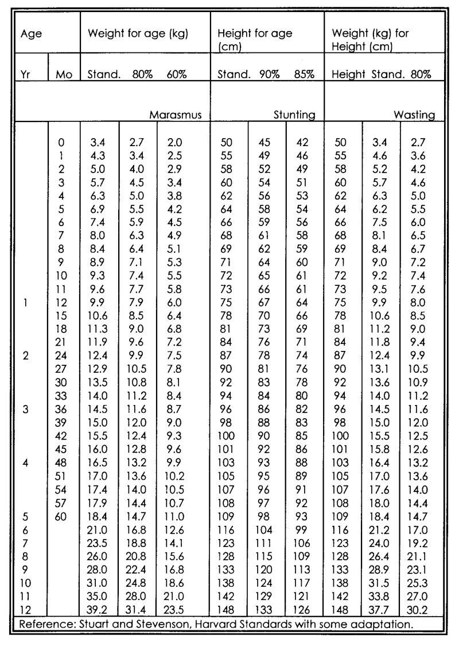
Intravenous Fluid Therapy in Paediatrics

1.) Maintenance fluid volume

Day of life ml/kg/day drops/min/kg Type of fluid

1 70 1 10% Glucose
2 90 1 "
3 110 1.5 10% Glucose/0.18% NS
(add 1 ml KCl/kg/day)
4 130 2 "
5 150 2 "

Week of life

1-4 150-200 2 "

Month of life

1-6 130-150 2 "
7-12 110-140 1.5-2 half strength Darrow's
13-24 90-120 1.5 "

Year of life

3-5 80-100 1-1.5 "
6-10 60-80 1 "
11-14 50-70 1 as in adults
adult 40-60 0.5 "

Electrolyte requirements in children (mmol/kg/day): Na+ 2-4; K+ 2; Cl- 2-4

2.) Extra fluid

a) In dehydration add the amount of additional fluid on top of the maintenance fluid volume!

b) In high fever (>39.0° C) give 10ml/kg/day more!

c) In meningitis, cerebral malaria and severe pneumonia, only give 80-100% of calculated volume!

d) In intestinal obstruction, add 50 ml/kg/day!

Change as early as possible to oral rehydration solution and oral drugs! You can kill a patient with intravenous fluids!

Diarrhoea WHO/IMCI Treatment Schedules (Plan A, B, C)

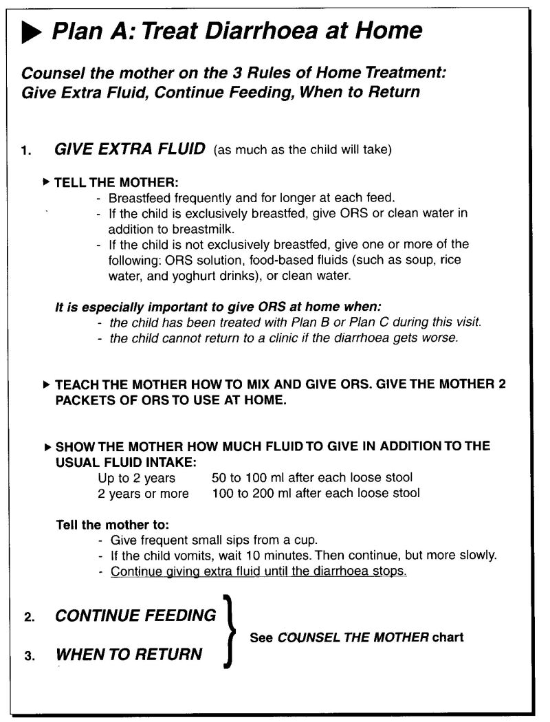
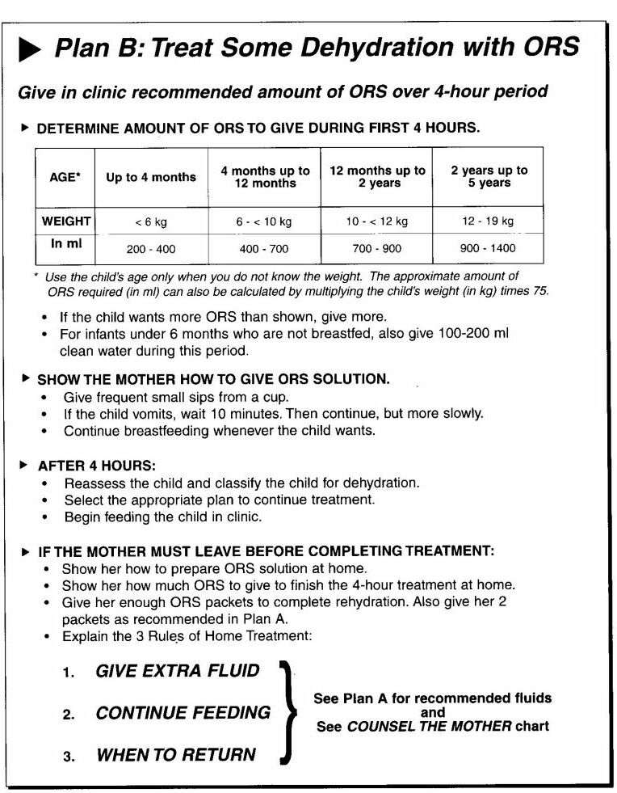

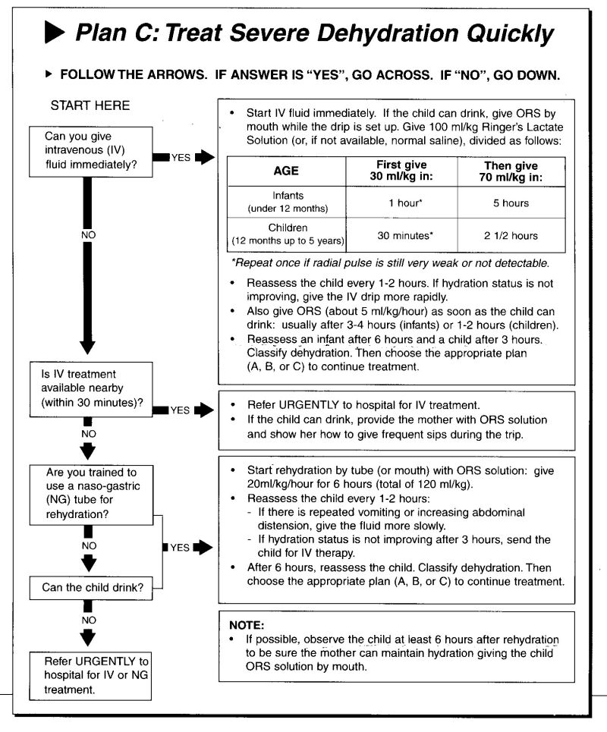

Neonatology

Neonatal Resuscitation - Basics

Principle

Try to anticipate the problems instead of reacting only to them! Take a good history before delivery in order to be prepared well!

Equipment

resuscitation table (flat)
good light
heat source (if available)
dry, clean (prewarmed) clothes, cap for premature newborns
suction device with different sizes of suction tubes (Ch 5, 6, 10)
ambu-bag with masks (size 0, 1)
laryngoscope with blades 0, 1
Magill forceps
endotracheal tubes (size 2.5, 3.0, 3.5, 4.0 ID)
strapping
small cannulas (24G, 26G)
small butterflies (19G, 23G, 25G)
umbilical vein catheter (you can use a normal feeding tube Ch 3.5 or Ch 5!)
medicine (see below)

Medication (Dosage)

If you need drugs for resuscitation of a newborn (especially adrenaline/epinephrine) then the prognosis for survival is very poor!

Adrenaline/Epinephrine (in the vial you get 1:1000 dilution: make 1:10000 dilution): give 0.1-0.5 ml/kg/dose i.v. (=0.01-0.05 mg/kg), you can increase up to 1.0 ml/kg/dose (0.1 mg/kg) (high dose, esp. for endotracheal application)

Volume expanders: NaCl 0.9% 10-20 ml/kg i.v., repeat as needed;
blood transfusion 10-15 ml/kg i.v. in haemorrhagic shock

Sodium bicarbonate (8.4% - dilute to 4.2%): 2 ml/kg 4.2% slowly i.v.

Naloxone: 0.1 mg/kg/dose (=0.25 ml/kg)

Atropine: 0.01-0.03 mg/kg/dose

Glucose 10%: 5 ml/kg i.v, then continuous infusion of Glucose 10%

Calcium gluconate 10%: 1-2 ml/kg/dose slowly i.v.

Phenobarbitone: 10 mg/kg/dose, can be repeated after 10-15 min

Route of administration of drugs

Oral administration does not work, intramuscular injections take too long a time to work.

peripheral i.v.: adrenaline, atropine, glucose/other fluids, naloxone, calcium, diazepam, frusemide, phenobarbitone, sodium bicarbonate

umbilical vein: as above

intratracheal: adrenaline, atropine, naloxone

intraosseous: adrenaline, atropine, glucose/other fluids, calcium, diazepam, sodium bicarbonate

Average birth weights according to gestational age

28 weeks 1000 g
30 weeks 1200 g
32 weeks 1600 g
34 weeks 2000 g
36 weeks 2600 g
40 weeks 3000-3500 g

Sizes of laryngoscope blades, endotracheal tubes and depths of intubation (according to body weight)

Body weight (kg) Tube size (ID) Depth of intubation(cm) Laryngoscope
oral nasal blade No.

1 2.5 7 8 0 (-1)

2 (2.5-) 3.0 8 10 1

3 (3.0-) 3.5 9 11-12 1

Size of suction tube according to size of endotracheal tube

Endotracheal tube (ID) Suction tube

2.5 Ch 6

3.0 Ch 6

3.5 and bigger Ch 10

Length of insertion of umbilical vein catheter (tip towards diaphragm)

Body weight (kg) Length of insertion (cm)

1 6

2 7

3 8.5

Assessment of the Newborn Infant

APGAR at 1 min (and earlier) - Continue to assess at 1, 5, and 10 minutes

7-10:
no special action except drying and gentle stimulation (if at all necessary)

4-6 (blue asphyxia):
proceed as follows: probably only drying, stimulation, suctioning and ventilation (with or without oxygen) necessary

0-3 (pale/white asphyxia):
proceed as below

There is a simplified score system proposed for assessment of asphyxia in newborns. This system only assesses breathing and heart beat.

Score
0 1 2
Breathing: Absent Gasping Regular
Heart beat: Absent < 100/min > 100/min

Score 4 is equivalent to APGAR 7-10.
Score 2-3 is equivalent to APGAR 4-6.
Score 1 is equivalent to APGAR 0-3.

Resuscitation Flow Chart

drying with (prewarmed) dry, clean towels
thereby tactile stimulation
cover especially premature infants well in order to prevent loss of body temperature (cap for head!)

suctioning of mouth (first!) and then nostrils
not to vigorous in order to avoid vagal stimulation

bag-mask ventilation: 40-60 times/min, if available with oxygen
if no response

intubation (preferably nasotracheal intubation) and continuation of ventilation
if no response

cardiac massage (2-finger-technique) 120 times/min
if no response

resuscitation with drugs: adrenaline, volume (NaCl 0.9%), sodium bicarbonate, naloxone, atropine, glucose etc.

Stop resuscitation after 20-30 min if no response!

Special conditions

In meconium aspiration use prewarmed normal saline for irrigation and biggest suction tube which fits into trachea or endotracheal tube!

After prolonged resuscitation give glucose i.v. to all infants! They tend to have hypoglycaemia and metabolic acidosis!
Physiological Background Information for
the Resuscitation of Newborns

Heart rate: 120-160/min

Respiration rate: > 40/min

Respiration pattern: through the nose using mostly the diaphragm

Blood pressure: according to body weight
but in general systolic BP 30-40 mmHg

Body surface: The head is about 20% of total body surface. In relation to
body weight, body surface is 3 times greater than in adults!

Temperature control:

Brown fat tissue (less in premature infants), insulating subcutaneous fat layer (thin in premature infants).

Loss of temperature due to convection, conduction (minimal), radiation and evaporation (high with wet infant). 4 times as rapid as in adults because of extensive surface area in relation to body weight.

Metabolic response to exposure to cold is limited, especially in starving or hypoxic infants.

Under normal environmental temperature in a delivery room (20-25° C), an infant's skin temperature falls approx. 0.3° C/min, the deep body temperature approx. 0.1° C/min immediately after delivery, meaning after 10 min of life the infant has lost 1° C of deep body temperature! The more immature the infant the more rapid the heat loss! Mortality of prematures is up to 80% if temperature is below 36° C, but only 20% if it is above 36° C!

Kangaroo Care

Principle: This type of care especially applies to premature newborns and small-for-date newborns. The mother is the primary care-taker of the newborn infant with regard to all aspects, regardless of birth weight and gestational age. The nurses and doctors “only” support the mother.

The aims are to lower morbidity and mortality from infection, hypothermia, hypoglycaemia, and from bradycardia and apnoea syndrome.

- After the initial adaptation phase (possibly including resuscitation procedures), within the first hour of life give the newborn to the mother in warm and clean clothes, and encourage breast feeding (if possible).

- The newborn is positioned between the mother’s breasts all the time.

- Teach the mother how to control temperature (warmth of hands and feet).

- Teach the mother how to keep the baby clean and dry (frequent checks, provide enough clean clothing all time).

- Teach the mother how to feed the newborn frequently even if he/she cannot suck or attach to the breast (NGT, spoon or cup feeding, expression of breast milk).

- Teach the mother to recognise signs of infection, bradycardia, cyanosis and apnoea (poor feeding, temperature, heart beat, respiration pattern, sole colour).

- Try to avoid as many invasive procedures as possible.

- Treat any complications (especially infections) early.

- Support and re-assure the mother under all circumstances.
Enteral Nutrition in Term and Preterm Newborns

Breast milk is always the best nutrition for newborns. Only in exceptional circumstances cow's milk (or breast milk substitutes = formula feeding) may be added or substituted (sick mother, orphan).

Day of life Amount of milk (ml/kg/d)

1 30-60
2 60-80
3 80-120
4 120-150
5 140-160
6 160-180
10 170-190
14 180-200
afterwards 200-250

Feeding frequency: fullterm newborns: ad libitum; fullterm sick newborns and newborns 2000-2500g: 5-6 meals/day; premature newborns 1500-2000g: 8 meals/day; premature newborns < 1500g: (8-) 12 meals/day

Premature newborns below 33/34 weeks of gestation usually need nasogastric or orogastric tube feeding (or similar measures as spoon feeding).

Fresh cow's milk as a substitute for breast milk in newborns and infants under 6 months of age

boil 2 parts of fresh cow's milk with 1 part of water
to each 100 ml of this mixture add 2.5 g sugar (half a teaspoon) and half a teaspoon of oil

start with full strength of this mixture
if the baby has difficulties with tolerating it then give 2/3 strength 3-5 days
afterwards return to full strength of this mixture

daily requirement: 150 ml/kg/day
(in premature infants even more up to 250 ml/kg/day)

Treatment of Term and Preterm Newborns

The 4 Basic Principles in Neonatology under Simple Conditions
1. Keep the baby warm!
2. Keep the baby clean!
3. Keep the baby dry!
4. Feed the baby appropriately!

Medication for certain conditions

Anaemia: in the first 5 days of life if Hb < 10 g/dl - transfuse blood 10 ml/kg
later if Hb is < 6-7 g/dl - transfuse blood 10 ml/kg
oral substitution - see under routine drugs

Apnoea/Bradycardia: Aminophylline 1% (10 mg/ml) solution p.o. 0.3-0.6 ml/kg/day (3-6 mg/kg/day) in 3
doses for 3-4 weeks

Birth asphyxia: diuretics and steroids have no proven effect at all on the outcome of birth asphyxia!
in convulsions:
Diazepam p.o./i.v./rectal - 0.2-0.4 mg/kg/dose 3-4 times/day (i.m. works too slowly!)
Phenobarbitone p.o./i.m./i.v. - loading dose 10 mg/kg up to 2 times the first day,
then continuation with 5 mg/kg/day in 3 doses
You can use these drugs in an alternating way!

Convulsions (rule first out meningitis, sepsis and malaria!):
Diazepam p.o./i.v./rectal - 0.2-0.4 mg/kg/dose 3-4 times/day (i.m. works too slowly!)
Phenobarbitone p.o./i.m./i.v. - loading dose 10 mg/kg up to 2 times the first day,
then continuation with 5 mg/kg/day in 3 doses
You can use these drugs in an alternating way!
Glucose 10% (or 5%) i.v. - 5 ml/kg/dose
Calcium gluconate 10% i.v. - 1-2 ml/kg/dose

Feeding: see guidelines page 24

Infusion: see guidelines page 15

Malaria: Quinine p.o./i.v. 30 mg/kg/day in 3 doses (10 mg/kg/dose); preferably oral route, i.v. high risk of
hypoglycaemia (if i.v. you can also use regimen with loading dose as on page 4)

Meningitis/Sepsis: Ampicillin i.v./i.m. 200-250 mg/kg/day in 3-4 doses for at least 7 days, then
Amoxicillin p.o. 50-75 mg/kg/day in 3-4 doses up to 21 days
plus Gentamicin i.m. 5-7.5 mg/kg/day in 1 dose for 10-14 days
optional during the first 4 days: Dexamethasone i.v. 0.6 mg/kg/day in 4 doses 15-20
min before antibiotic!
(If available, give Ceftriaxone i.v./i.m. 50-75 mg/kg/day in 1 dose or Cefotaxime i.v. 100-150 mg/kg/day in 3 doses instead of Ampicillin; in staphyloccocal sepsis add Cloxacillin i.v. 100-150 mg/kg/day in 3 doses)

Pemphigus neonatorum: Erythromycin p.o. 40-60 mg/kg/day in 3-4 doses for 3-5 days
or Cloxacillin p.o. 30-50 mg/kg/day in 3-4 doses for 3-5 days

Pneumonia (e.g. aspiration): Ampicillin i.v./i.m. 100-150 (-200) mg/kg/day in 3-4 doses for at least 5 days,
then Amoxicillin p.o. 50-75 mg/kg/day in 3-4 doses up to 14 days
plus Gentamicin i.m. 5 mg/kg/day in 1 dose for 5-7 days

Routine drugs for all premature babies (< 37 weeks) - assess prematurity by using the Finnström score!
Vitamin K i.m. 0.5 mg if <1500 g, and 1 mg if >1500 g, after delivery. Repeat on day 3.
Aminophylline 1% (10 mg/ml) solution p.o. 0.3-0.6 ml/kg/day (3-6 mg/kg/day) in 3 doses for 4-6
weeks (to all prematures < 35 weeks)
Folic acid solution (1 mg/2 ml) p.o. 0.1 ml/kg/day (50 microgram/kg/day) in 1 dose for 4-6 weeks
from the 3rd week of life
Ferrous acid solution p.o. 1 drop/kg/day (2-3 mg/kg/day elementary iron) in 1 dose for 4-6 weeks
from the 3rd week of life
Multivitamin p.o. 1/2 tablet/day in 1 dose for 4-6 weeks from the 3rd week of life
Vitamin D 500 units/day over 6 weeks from the 3rd week of life
All newborns: after delivery Povidone Iodine 2.5% eye drops x 1

N.B: Chloramphenicol in newborns has a different dosage (avoid if possible)
< 1 week: 25 mg/kg/day in 1 dose /
> 1 week: 50 mg/kg/day in 2 doses
Finnström Maturity Score in Newborn Infants

Ref.: Finnström, Acta Paediatrica Scandinavica 1977, 60: 601 ff.

Score | 1 | 2 | 3 | 4
Breast size | < 5 mm | 5 – 10 mm | > 10 mm
Nipple formation | No areola nipple visible | Areola present, nipple well formed | Areola raised, nipple well formed
Skin opacity | Numerous veins and venules present | Veins and tributaries seen | Large blood vessels seen | Few blood vessels seen or none at all
Scalp hair | Fine hair | Coarse and silky individual strands
Ear cartilage | No cartilage in antitragus | Cartilage in antitragus | Cartilage present in antihelix | Cartilage in helix
Fingernails | Do not reach finger tips | Reach finger tips | Nails pass finger tips
Plantar skin creases | No skin creases | Anterior transverse crease only | Two-thirds anterior sole creases | Whole sole covered

Total points scored:
7 8 9 10 11 12 13 14 15 16 17 18 19 20 21 22 23

Days of gestation:
191 198 204 211 217 224 230 237 243 250 256 263 269 276 282 289 295

Weeks of gestation:
27+ 28+ 29 30 31 32 33 34 35- 36- 36½ 37½ 38½ 39½40+ 41+ 42+

Notes:

Test fingernails by scratching them along your hand.
Skin creases are the deep creases not the fine lines.

Intra-uterine Growth Chart

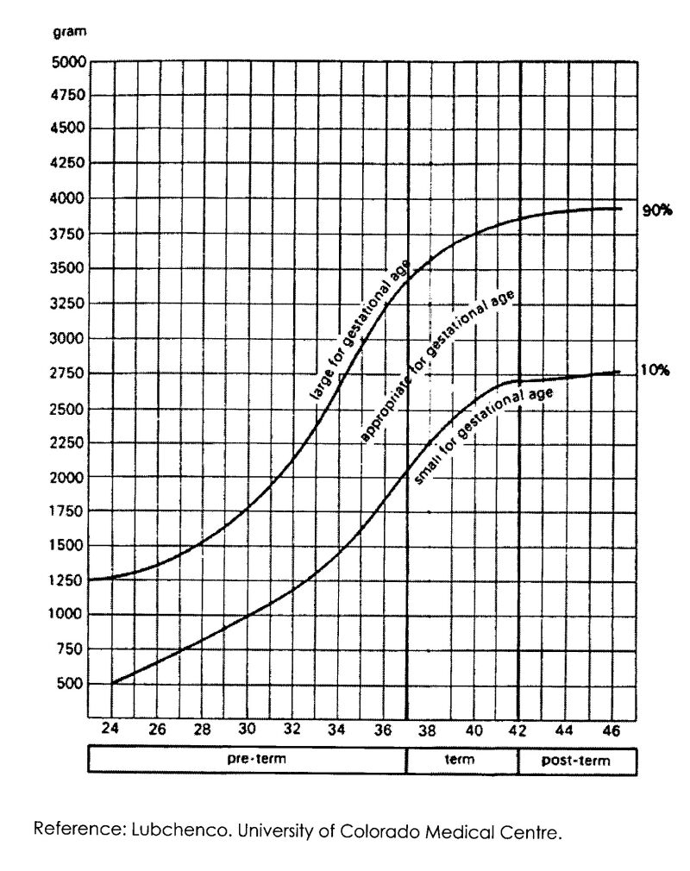
Appendix

Reference Values

Respiration Rate

Age | Upper Limits
< 2 months | < 60/min
2 months - < 1 year | < 50/min
1 - < 5 years | < 40/min
5 - < 12 years | < 30/min
> 12 years | < 25/min

Pulse Rate

Age | Lower Limits | Average Rates /min | Upper Limits
Newborn | 70 | 120 | 170
1-11 months | 80 | 120 | 160
2 yr | 80 | 110 | 130
4 yr | 80 | 100 | 120
6 yr | 75 | 100 | 115
8 yr | 70 | 90 | 110
10 yr | 70 | 90 | 110
12 yr | 65 | 90 | 110
14 yr | 60 | 85 | 105

Blood Pressure

Age | Mean Systolic ± 2 SD | Mean Diastolic ± 2 SD
1 month | 80 ± 16 | 46 ± 16
6 months to 1 yr | 89 ± 29 | 60 ± 10
2 yr | 99 ± 25 | 64 ± 25
4 yr | 99 ± 20 | 65 ± 20
5 yr | 94 ± 14 | 55 ± 9
7 yr | 102 ± 15 | 56 ± 8
9 yr | 107 ± 16 | 57 ± 9
10 yr | 111 ± 17 | 58 ± 10
12 yr | 115 ± 19 | 59 ± 10
13 yr | 118 ± 19 | 60 ± 10
The width of the cuff should cover about 2/3 of the length of the upper arm. The appropriate cuff for children is about 9 cm wide.

Red Blood Cell Values

Age | Hb (g/l) | PCV (1/l) | RBC (x 10¹²/l)
Birth (cord blood) | 165 ± 30 | 0.54 ± 0.10 | 6.0 ± 1.0
3 months | 115 ± 20 | 0.38 ± 0.04 | 4.0 ± 0.8
1yr | 120 ± 15 | - | 4.4 ± 0.1
3-6 yr | 130 ± 10 | 0.40 ± 0.04 | 4.8 ± 0.7
10-12 yr | 130 ± 15 | 0.41 ± 0.04 | 4.7 ± 0.7
Values are mean ± 2 SD (95% range). Hb: haemoglobin; PCV: haematocrit; RBC: red blood cell count

Haemoglobin (g/l) in Iron-sufficient Preterm Infants

Age | Birthweight 1000-15000 g | Birthweight 1501-2000 g
2 weeks | 163 (117-184) | 148 (128-196)
1 month | 109 (87-152) | 115 (82-150)
2 months | 88 (71-115) | 94 (80-114)
3 months | 98 (89-112) | 102 (93-118)
4 months | 113 (91-131) | 113 (91-131)
5 months | 116 (102-143) | 118 (104-130)
6 months | 120 (94-138) | 118 (107-126)
Values are mean (range).

Normal Total Leucocyte Counts

Age | Mean Total Leucocytes | Range of Total Leucocytes
Birth | 18.1 | 9.0-30.0
12 hrs | 22.8 | 13.0-38.0
24 hrs | 18.9 | 9.4-34.0
1 week | 12.2 | 5.0-21.0
2 weeks | 11.4 | 5.0-20.0
1 month | 10.8 | 5.0-19.5
6 months | 11.9 | 6.0-17.5
1 yr | 11.4 | 6.0-17.5
2 yr | 10.6 | 6.0-17.0
4 yr | 9.1 | 5.5-15.5
6 yr | 8.5 | 5.0-14.5
8 yr | 8.3 | 4.5-13.5
10 yr | 8.1 | 4.5-13.5
16 yr | 7.8 | 4.5-13.0
21 yr | 7.4 | 4.5-11.0
Values are mean (95% confidence limits) x 10⁹/l.

